Andrew Rutherford

CSCI 3104

CPU: 2.8 GHz Intel Core i7

Ram: 16 GB 1600 MHz DDR3

OSX Yosemite

Homework #2



On my honor, as a University of Colorado at Boulder student, I have neither given nor received



1. It takes O(mn) time to multiply x and y.
   1. Multiply(x, floor(y/2)) shifts y one bit a total of n number of times. The run time for this is O(n). Then either a multiplication by 2 or a multiplication by 2 and an addition will occur which is also O(n). These operations combined result in O(mn) running time.
2. 1. GCD:
      1. 770 = 2 \* 5 \* 7 \* 11
      2. 546 = 2 \* 3 \* 7 \* 13
      3. GCD = 2 \* 7 = 14
   2. Euclid:
      1. Euclid(546, 770 mod 546) 770 mod 546 = 224
      2. Euclid(224, 546 mod 224) 546 mod 224 = 98
      3. Euclid(98, 224 mod 98) 224 mod 98 = 28
      4. Euclid(28, 98 mod 28) 98 mod 28 = 14
      5. Euclid(14, 28 mod 14) 28 mod 14 = 0
      6. If (b == 0) return a return 14

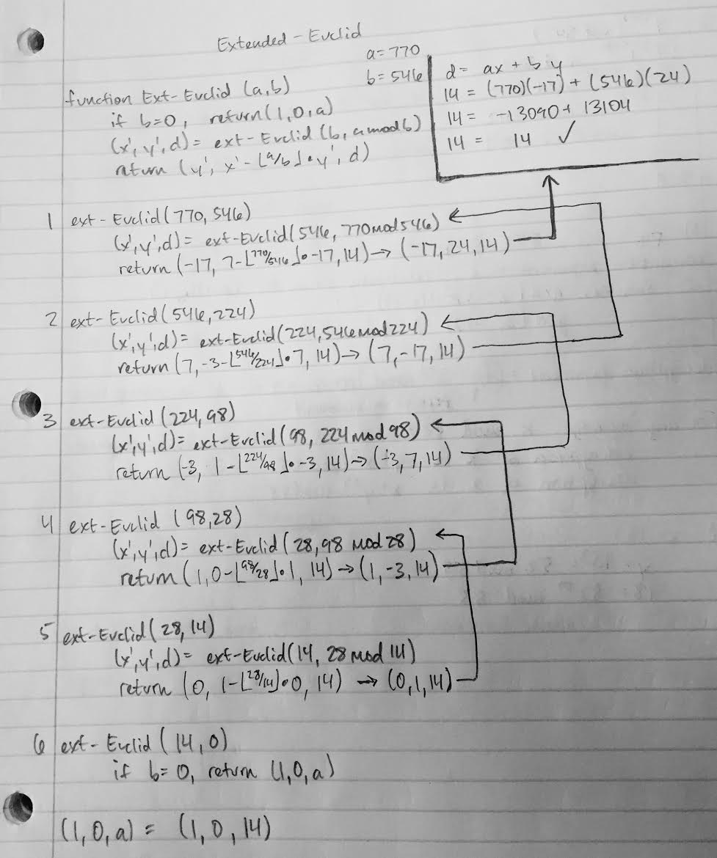

77293 mod 342

(73)2431 mod 342

3432431 mod 342

12431 mod 342

1 mod 342 = 1

